Drinkworks: Home Bar by Keurig

**1. Intro: Is Drinkworks a good product? What problem is it trying to solve? What is its reference market?**

We can divide people in 3 groups: people that like making cocktails at home, people that like drinking cocktails but don’t like making them, people that don’t like drinking cocktails.

Of these 3 categories only one of these 3 would buy the Drinkworks. People that like making cocktails would not buy the machine because for them the enjoyment is in the process of making the cocktail, which is all done by the machine. People who don’t like drinking cocktails would use the product for beer but for that it would be cheaper to just buy canned or bottled beer.

We also see that what they say about their target customer doesn’t make that much sense. They say the target customer tends to be a ‘hoster’ who wants to step up the experience when they’re hosting. This is only really true for hosts that don’t make cocktails at home, since the experience will be a step down because the cocktails will be worse than

what the host used to make.

Drinkworks’ product is trying to solve the complexity of making a cocktail at home and make it more convenient. It really makes it simpler, since you only have to put a pod in the machine, but it is only more convenient if you have a lot of people or you don’t make cocktails at home. The machine takes 10 minutes to cool down and 1 minute to make a cocktail, in that time you can actually make a reasonable number of cocktails. If you don’t make cocktails at home, then the price they are asking is probably too much for a normal person to get into drinking cocktails at home (it would be cheaper just to buy the ingredients).

Their reference market is the pod coffee market. If we compare this product to, for example, a Nespresso product, this product makes no sense. The upfront cost of the product makes it inaccessible for most people. Nespresso offers their machine when you buy the pods so there really isn’t that much up front cost on the machine. The Nespresso machine also takes way less time to get ready (<1 minute), so the convenience level is way bigger since making an espresso from scratch takes at least 5 minutes. On the contrary, you can make a cocktail in less time than it takes the Drinkworks product to cool down.

In conclusion, the Drinkworks product is not a good product because their appeal is too niche. It only makes sense for a person to buy the product if they are hosting a lot of parties with a lot of people. This is because, even if you like drinking cocktails but don’t like making them (the only group of people who would buy this product) it is cheaper to make your own cocktails and it is faster.

**2. How do you characterize the target market segment(s) of Drinkworks? What is its potential target market size?**

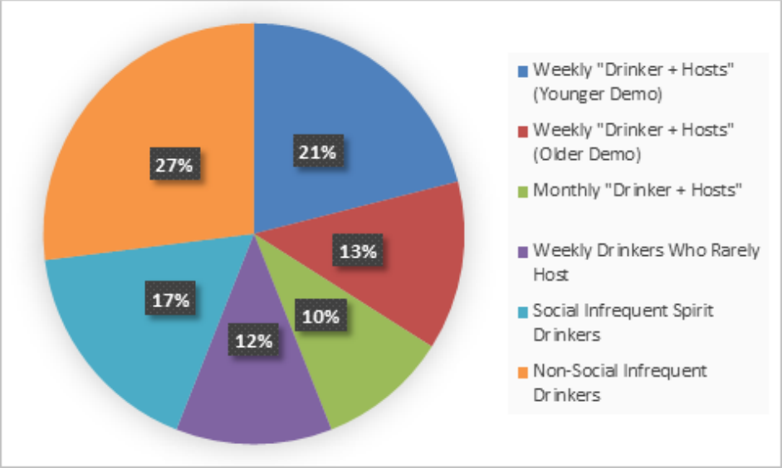

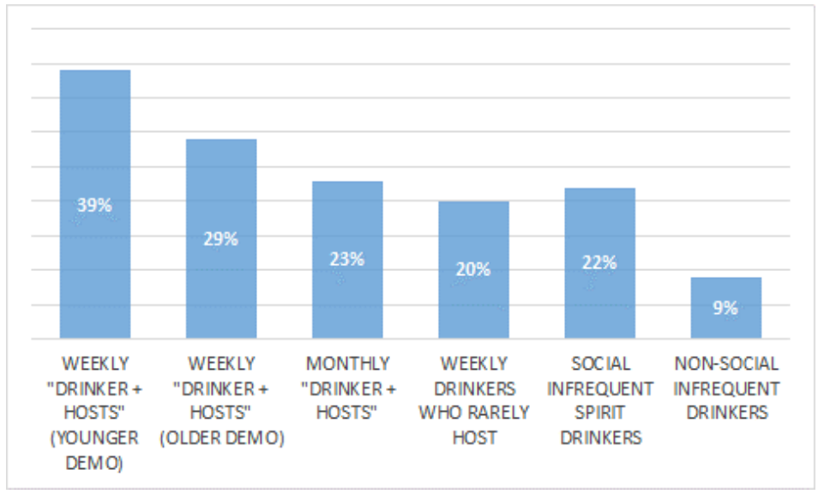

Demographic characteristics that should be analyzed:

* Alcohol consumption frequency
* Hosting frequency
* Age
* Keurig device ownership

From the studies carried out by the company (pricing the appliance at $199 and the pods at $4), we can see that the product is more appealing to weekly drinkers who are also frequent party hosts.

This product would target, at most, 23% of the total market (US people, aged 25-64 that consumed any type of alcohol in the last four weeks). This is a small percentage, so we can consider this a niche business.

**3. What is Drinkworks' value proposition, and what is its positioning in the market? What Pods should be introduced?**

Value Proposition: Convenience

Keurig is a well-established company in the coffee-brewing and soft drinks market, while Anheuser-Busch InBev is a big company in the beer-brewing market. Being created through a joint venture between these two companies, Drinkworks will get to the market with some of that recognition. …

Regarding the pods, there are two approaches that the company could take, in our view.

The first approach is to only introduce the non-alcoholic mixer pods to the market. This would be the easiest approach since these pods can be sold and distributed without any regulation problems. Besides being the easiest pods for the customers to comprehend, they also allow customers to choose their preferred liquor brand and amount to add to the pod. However, this approach goes against the company’s value proposition (convenience), as people would have the additional task of buying and adding the liquor to the pod. Ready-to-Drink pods would be much more convenient.

The second approach is to only sell alcoholic pods (cocktail and beer/cider). Although this approach would implicate a lot more logistic work, it would go directly into the company’s value proposition. Alcoholic pods could be sold at liquor stores and online.

Selling both alcoholic and non-alcoholic pods would not be a great idea because it could generate some confusion among customers (selling locations and the pods themselves).

**4. How should the device and Pods be priced?**

According to the table of the Exhibit 5, the device should be priced under $100, in order to motivate people who wouldn’t be buying to buy it, since there are 42% of people not interested in buying at any price, which is a very high percentage. Also all the people who would buy at the prices of the table would buy it anyhow.

The cocktail pods should be priced around $5.00 because there are a good percentage of people interested in buying and its much cheaper than the cocktails selled at bars.

With the same ideas above, the price of the non-alcohol mixer pods should be around $1.50 and the price of beer/cider pods should be around $2.50.

**5. Will Drinkworks be the next billion-dollar opportunity of Keurig and AB InBev? What are the risk opportunities, and what would you recommend Keurig to do to address them?**

**SWOT Analysis**

Opportunities:

* Most households in the US have consumed any form of alcohol in the last weeks and this number is growing, which might mean that the potential market is growing.

Threats:

* Competitor company Bartesian planning to launch worldwide. This company is called the “Keurig of cocktails”.
* Distribution of alcoholic goods is tricky in the US since there are a lot of regulations about it and they might change from state to state.

Strengths:

* Drinkworks can use Keurig and AB InBev’s names to market their product, which might give it some traction in the market.
* The device can last long (5 or more years).
* After the water is chilled, making a cocktail is extremely fast (around 1 minute).

Weaknesses:

* The device takes a lot of time to chill the water (10 minutes). The solution to this is to leave the device plugged in, but this is also not ideal since it consumes energy even when not being used (has to keep the water chilled).

In our opinion, Drinkworks will not be the next billion-dollar opportunity of Keurig and AB InBev. We believe the product targets a very niche market and, in order to be profitable, would have to be sold at high prices. Furthermore, it’s a difficult product to introduce to the market since people will likely not spend around 300$ in a device without knowing it works as expected first.